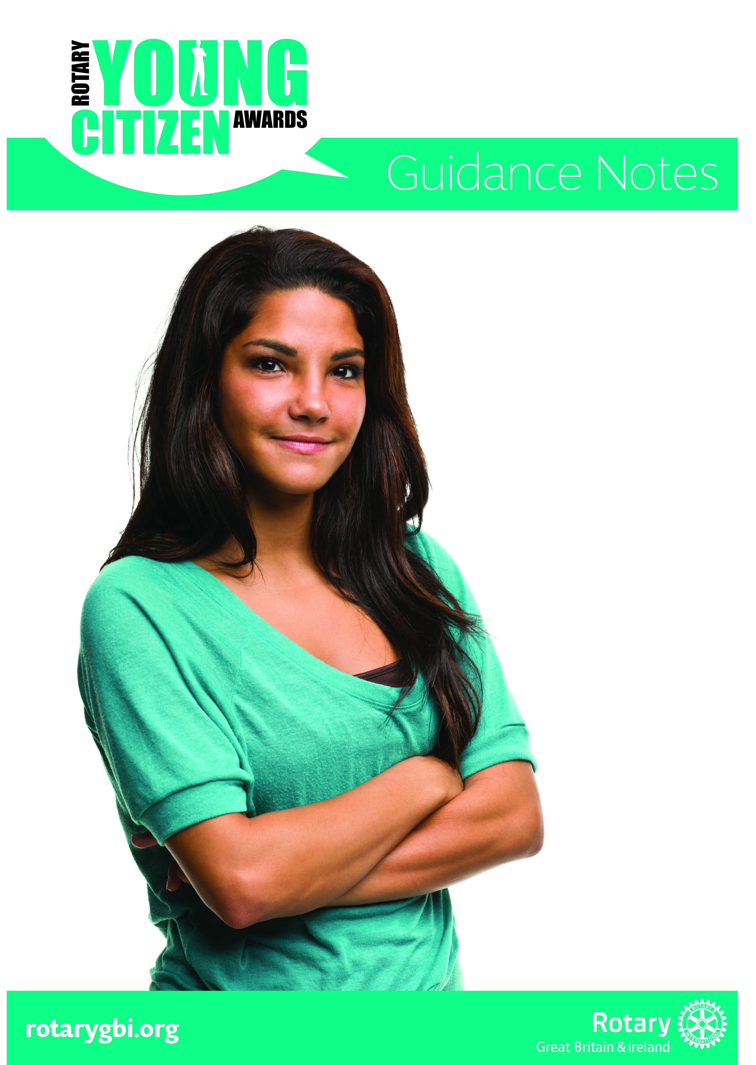
Guidance Notes for 2018/19

The Rotary International Great Britain and Ireland (RotaryGBI) Rotary Young Citizen Awards (YCA) were created to celebrate the achievements and commitment of inspiring young people across Britain and Ireland.

The YCAs are internally managed by the RotaryGBI Home Team (Youth) with one Rotarian working as the responsible liaison for club contact. The Rotarian liaison for 2018/19 is Eve Conway.

The awards are to showcase and celebrate the positive citizenship and important responsibilities assumed by many young people under the age of 25.

YCA winners receive a trophy, certificate and a prize of £500 for the winners’ nominated charity or good cause. The awards will be presented by BBC TV Presenter Ellie Crisell at the Rotary Showcase (Conference) being held in Nottingham on Sunday, 12th May 2019. Awardees will need to supply information detailing to which charity or good cause their prize cheque should be made payable in advance of their attendance at the Showcase.

Those nominated do not have to be working on a Rotary project to be eligible for an award. What matters is that they, individually or as part of a group, have made a positive difference which is recognised by a local Rotary club as worthy of a nomination; for example, they might be champions in their school or local community, young carers, fundraisers, volunteers or have shown particular courage in some way.

Rotary clubs, Rotary districts and the RotaryGBI Home Team (Youth) recognise that there are many young positive role-models who are going out of their way to make a difference to our world and the Awards showcase the good that young people are doing and these are the success stories of all the Rotary Young Citizen Awardees.

Every nomination will receive a personalised certificate from Rotary (signed by the RotaryGBI President) which will recognise the achievement that led to being nominated by the local Rotary club. The Rotary club is responsible for submitting nominations to the organisers by the date indicated.

All entries will be reviewed and a short list drawn up before the winners are identified by the judging panel.

Rotary clubs and districts can find more information on the Youth Service pages of the RotaryGBI website. You can find out about last year’s winners on: Rotary Young Citizen Award Winners 2018

If Young Citizen Nominees or Awardees are under the age of nineteen, they are able, if eligible according to the criteria, to be nominated for the Diana Award (please read their website - www.diana-award.org.uk) which was set up in 1999 to act as a lasting legacy to Diana, Princess of Wales, who firmly believed that young people have the power to change the world for the better.

Nominations
If you’re looking to nominate a young person or group for a Rotary Young Citizen Award, then you’ve already decided that these young people are worthy of recognition; by nominating them, you are acknowledging their commitment to whatever effort they have made.

The Rotary Young Citizen Award has no set categories and therefore does not limit who can enter. Individual young people and groups of young people, aged under 25 years, can be nominated by individual Rotary clubs. Clubs can make more than one nomination.

Please provide as much information about the young person/people nominated as possible. This can include newspaper or other media coverage and videos (from YouTube, etc.) but don’t rely on this as the only evidence of work done by the nominee. Other information can include statements from the young people’s school or from organisations or people who have benefitted from their help, charity numbers, schemes which are up and running and speaking to those involved, obtaining statistics, financial figures if relevant, etc. The nominee(s) can also produce a video of their work/project as part of the application, use of a mobile phone is acceptable.

There is also a separate Rotary Young Citizen WheelPower Sports to recognise and highlight the achievements and contribution as a positive role model to others of a wheelchair sports participant or a group. The criteria for this award is;

- Aged 25 years of age or under.
- Open to an individual or group.
- Must have made a positive social impact on a community through action, and be a positive role model for others.
- Must be able to demonstrate the importance of sport in transforming their life.
- Must have shown a determination, dedication and commitment in their chosen sport

Athletes in receipt of on UK Sport podium level funding are not eligible for this award.

In 2018/19 we are introducing the Rotary Young Citizen Peacekeeper Award, reflecting Rotary’s area of focus on Peace and Conflict Prevention/Resolution, to recognize young people, aged under 25, who have made a significant contribution by building peace and understanding, whether in their school, local community, by for example helping tackle anti-social behavior and youth crime, perhaps as peer mentors, or with a peace project internationally. Again, nominations need to be made using a separate form and can be an individual or group.

Please nominate any young people you know who, in your club’s opinion, have made a difference locally, nationally or internationally and who deserve recognition of their personal achievements.

Nomination deadline: Rotary Young Citizens Awards is Thursday, 28th February 2019.

Public Relations
Clubs must wish to advise their YCA nominees that, should they be chosen as a winner, the BBC may be in contact to make a short film about their nomination and do an interview with them.

Specific details and privacy statements will be discussed, and relevant consent sought, with the winners and/or parents/guardians, in advance.

The Rotary Public Relations team would also be in contact with the District Public Relations officer to ensure appropriate local and National PR coverage to celebrate the winners’ achievements, with appropriate consent.

‘Winners’ Attendance at the Rotary Showcase (Conference) and Prizes
The winners are invited to the Rotary Showcase to receive their award.

The RotaryGBI Home Team (Youth) will assist with a grant to a maximum of £200 per winning nomination. Nominating Rotary clubs/districts should make their grant claim for reimbursement towards travel and accommodation expenses of the Young Citizens following Showcase directly to the accounts department at the Rotary Support Centre within 14 days following Showcase.

Nominating clubs or districts may need to assist with other costs associated with winners’ attendance, such as, accommodation, transportation to and from the event and any sustenance above the £200 Grant.

The YCA winner(s) accommodation, transportation to and from Showcase and any sustenance arrangements are the responsibility of the nominating club.

Youth Competitions
The Rotary Young Citizen Award is one of seven competitions organised by Rotary International in Great Britain and Ireland for young people. The others are: Young Chef, Young Musician, Young Photographer, Young Writer, Youth Speaks and the Technology Tournament. To find out more about these competitions and other opportunities please contact your local Rotary club or use the following link: Youth Competitions

IMPORTANT RESTRICTIONS TO NOTE: Please note that nominations and supporting information sent electronically MUST NOT EXCEED 15Mb per email sent. Emails over this limit will not be received at the Support Centre. Alternative options are to send the nomination and supporting information across several emails or contact Andy Smith, Rotary CDS Team, to organise a Dropbox facility.

All nominations received at the Support Centre will be acknowledged via email and listed on the RotaryGBI website as received. It is the responsibility of the nominating club/district to check that their nomination(s) has been received by the Support Centre and resolve any queries with Andy Smith before the closing date.

RIBI Policies and Procedures to be followed
Child Protection/Safeguarding: The RIBI Safeguarding Guidelines MUST be followed. Rotary Young Citizen Award organisers are advised to liaise with Club and/or District Safeguarding Officers.

General Data Protection Regulations (GDPR): With GDPR effective 25 May 2018, all personal information collected MUST be GDPR compliant, including information for all youth competitions and awards. With this in mind, all of the forms and procedures for youth competitions and awards have been reviewed and updated to be GDPR compliant.

The following has been revised for the 2018/19 youth competitions and awards and MUST be adhered to by all those administering, collecting or holding personal information in respect of the youth competitions and awards:-

- A supplementary privacy notice compliant to GDPR has been introduced for the Rotary Young Citizen Awards and must be publicised and adhered to by all those involved with the awards process. The supplementary Privacy Notice is on the reverse of the nomination form.
- Nomination forms have been revised to be GDPR compliant. Those entering a nomination for the Rotary Young Citizen Awards must only use the revised GDPR compliant nomination forms. The co-ordinator collating the forms at the Rotary Support Centre, Andy Smith, will check that the appropriate GDPR compliant nomination form was used. Any entries submitted on the incorrect forms will be referred back to the nominating Rotarian.
- Written permission to use photos for publicity purposes must be obtained from the parent/guardian and must be sought only after the winner has been identified. Permission for photographs should be sought in conjunction with the arrangements to contact the winner regarding PR opportunities.
- All forms upon which personal information is collected must have a separate ‘privacy notice’ section ON the form. This section must refer to the general privacy notice for Rotary International in Great Britain & Ireland, together with the club and district privacy notices. In addition, there should be a supplementary privacy notice specifically relevant to the award, i.e. detailing a summary of what personal information is collected, how it will be used, who it will be shared with at the various stages and for what purpose. The privacy notice on the form must also advise when the personal information will be destroyed (see below).

- Where the nominee is under 18 years of age at the time the nomination form is signed and submitted, then parental/guardian consent must be obtained. A nominee under the age of 18 years of age is not permitted to sign the nomination form. Where the nominee is 18 years of age or over, care should be taken to ensure that the individual is legally eligible to sign the consent form.

As per the parameters set by the RotaryGBI Home Team and the privacy notice for all youth competitions/awards, all documentation, including spreadsheets, databases, etc, (whether held at club, district, Rotary Support Centre level) relating to youth competitions/awards containing personal information must be destroyed 3 months after the date of the relevant youth competition NATIONAL final/presentation (in the case of the Young Citizen Award, the documentation must be destroyed 3 months after the presentation date at the Rotary Showcase). In other words, a club involved in a Young Citizen Awards has a responsibility to ensure that all those persons involved in administering the award and holding personal information, must destroy the nomination forms and all other documentation/spreadsheets etc. associated with the Young Citizen Award by the 14th August 2019.

