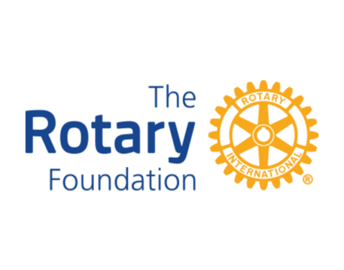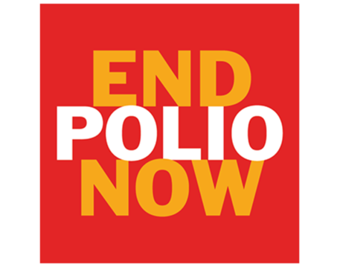
July 2023
DISTRICT 1220

District Grant Proposals required by 10 September 2023 latest.

TO ALL ROTARY CLUBS IN DISTRICT 1220

I am contacting you on behalf of YOUR District 1220 Foundation Team.

Proposals for Foundation Grants in the 2023/24 Rotary year will be considered by the Grants sub -committee in the third week of August. We anticipate having funds of approximately £20,000 available (the final sum is subject to confirmation by The Rotary Foundation and fluctuating exchange rates) to support grant applications from clubs. This is sufficient to support a minimum of 13 projects. If you want to have a proposal considered, please complete Appendix 3 of the Grants Information Pack (attached) and return it to me asap and by not later than the 10 September 2023.

We have maintained the maximum grant at £1,500 (provided that your Club can at least match this amount) to increase the number of projects that can be supported. However, this is a maximum sum but, we can consider smaller project sums.

The new "Foundation Grants Information Pack" which explains the Grant application process, eligibility criteria and contains all the relevant documentation as Appendices will soon be available at: -

http://district.rotary1220.org/service-committees/foundation or direct, on application to the Chairman of the District Grants Committee.

I strongly encourage you to read the Introduction to this document that explains how your club can benefit from Foundation support.

Please note:

- Projects can be considered for humanitarian purposes both locally as well as overseas;
- Consideration will continue to be given to support for Food Banks via District Matching Grants.
- If oversubscribed, priority will be given to Clubs who meet their Annual Giving target.

The amount of money available for District Grants is totally related to the amount of Annual Giving that Clubs in District 1220 provide. Please continue to support The Rotary Foundation.

You do not need to have all the detail of your project in the initial outline proposal. The Proposal form which is available from the District Website or direct from me, is a very brief one-page outline with a clear indication of costs.

You will not have to complete any further documentation until you have received the green light to make an application based on your proposal, hopefully during September.

Please do not complete the detailed Application until we inform you that your initial proposal has been accepted.

We cannot fund projects retrospectively so projects supported by a District Grant cannot commence until full approval of the Grant Application has been given.

If you are considering a Grant Application, please feel free to contact me or any other member of the Grants-Subcommittee and we can advise on the eligibility of your proposal and take you through the process.

Remember we're here to help! – and we want to help you spend effectively what is after all, your money!

Yours in Rotary

Michael.

Michael Longdon

Chair

District 1220 Grants Sub-Committee.

michaellongdon@sky.com

01623 378990 (H)
07858 441229 (M)

ML072023

