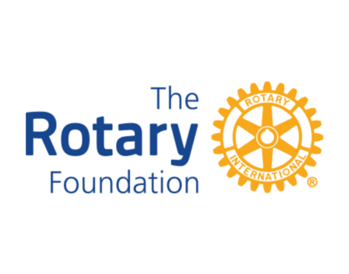
May 2024
District 1220 Grant Proposals required by 31st July 2024.

To all Rotary Clubs in District 1220

Proposals for Foundation Grants in the 2024/25 Rotary year will be considered by the Grants Sub-committee in the first week of August. We anticipate having funds of approximately £20,000 available (the final sum is subject to confirmation by The Rotary Foundation and fluctuating exchange rates) to support grant applications from clubs. If you would like to have a proposal considered, please complete Appendix 3 of the Grants Information Pack (attached) and return it to d1220grants@outlook.com no later than 31st July 2024.

The maximum amount of funding available will be £1500 per grant and this must be matched by the club. Please note that this is the maximum that you could receive. Funding for smaller amounts will obviously be considered.

The new "Foundation Grants Information Pack" which explains the Grant application process, eligibility criteria and contains all the relevant documentation as Appendices is available at:
http://district.rotary1220.org/service-committees/foundation
or by sending an email to d1220grants@outlook.com .

I strongly encourage you to read the Introduction to this document that explains how your club can benefit from Foundation support.

Please note:
- Only qualified clubs can be considered for grants. To be qualified they must meet the following criteira:
  - Have attended the Foundation session at this year’s District Assembly.
  - Have completed the online Grants training in the Rotary Learning Centre.
  - Have signed the MoU for Grants (available on the District website).
- Projects can be considered for humanitarian purposes both locally as well as overseas.
- If oversubscribed, priority will be given to Clubs who have donated to the Rotary Foundation.

The Proposal form which needs to be submitted by 31st July 2024 is a brief one-page outline with a clear indication of costs.

Once you have been informed that the proposal has been approved the full application should be submitted.

We cannot fund projects retrospectively so projects supported by a District Grant cannot commence until full approval of the Grant Application has been given.

If you are considering a Grant Application, please feel free to contact me or any other member of the Grants Sub-committee and we can advise on the eligibility of your proposal and take you through the process.

The amount of money available for District Grants is totally related to the amount of Annual Giving that Clubs in District 1220 provide. Please continue to support The Rotary Foundation.

Yours in Rotary

Ian Priestley

Chair
District 1220 Grants Sub-Committee.
D1220grants@outlook.com
07818 602087

