District 1220 Foundation Committee
Foundation Grants – Global Grant Proposal
2025– 2026 Rotary year
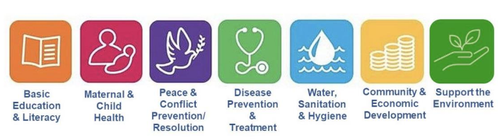

APPENDIX 7: GLOBAL GRANT PROPOSAL AND REQUEST FOR DDF SUPPORT FORM

To be submitted to District Foundation Grants Sub Committee Chairman, Roy Bright RC Eckington & District by e-mail rfdgrants1220@gmail.com.

Note: Global Grant Proposals and funding requests are required as early as possible to ensure funding is available but can be submitted at any time during the Rotary year.

Global Grant Proposal

Rotary Club: ------------------------------------------------- Date Submitted: ------------------------------

Contact Name: ---------------------------------------------- Telephone No. ---------------------------------

Email address: ----------------------------------------

Project Description (outline, objectives, beneficiaries, country etc.),
(Global Grant No. if application already started online).

Rotarian involvement

Sustainability (how will benefit be ongoing)

Publicity:

Estimated Start Date: Estimated Completion Date:

Global Grant | £ | $ (Estimate)
Total Project cost:
Planned Club(s) Contribution(s)
District DDF Requested

If you require any advice or if your proposal has not been acknowledged within five days of sending, please contact the District Grants Committee Chair: Roy Bright at : rfdgrants1220@gmail.com

