District 1220 Foundation Committee
District Grants Proposal Form
2025– 2026 Rotary year
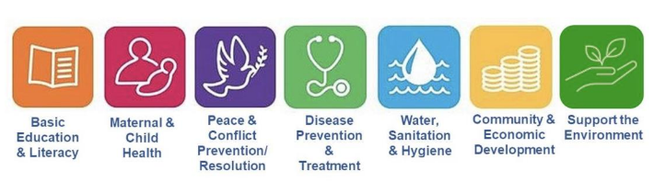

To be submitted to District Foundation Grants Chairman, Roy Bright, RC Eckington & District by 31st July 2025, or sooner, by e mailto:rfdgrants1220@gmail.com

District Grant Proposal

Rotary Club---------------------------------------------------------------- Date Submitted: ----------------
Contact Name: Telephone No.

Email address:

Project Description (brief outline, beneficiaries, country)

Rotarian involvement

Sustainability (how will benefit be ongoing)

Publicity:

Estimated Start Date: Estimated Completion Date:

Project Funding Plan:

Total Project cost: | £
Planned Club Contribution | £
District Grant Request | £
District Grant request can be the up to the Planned Club Contribution subject to a maximum of £1,500.00

If you require any advice or if your proposal has not been acknowledged within five days of sending, please contact the District Grants Committee Chair: Roy Bright by e mail: rfdgrants1220@gmail.com

